Title (ENG)
Author^{*,1}, co-author²
¹Organization
²Organization
Extended abstract (ENG)
In this section, please briefly and concisely state the fundamental principles of your paper in English. You can use the structure of the extended abstract below. The length of the extended abstract in English is expected to be 1-2 A4 pages.
Introduction

Materials and methods

Results

Conclusions

Keywords: (ENG) Please enter at least 5 keywords
- Introduction
In this section of your paper, please introduce the topic and provide a broader context.
- Heading
Other headings and sub-headings levels are not strictly defined. Suggestion for a structure of the paper is to structure the paper as follows:
- introduction,
- current state of knowledge/description of methodology,
- results,
- discussion,
- conclusion,
- acknowledgements and
- references.
  - Heading
Use the predefined numbered heading styles Heading level 2 and Heading level 3 for the individual headings.
    - Heading
If you need another level of headings, you can use the predefined style Heading level 4, which is no longer numbered.
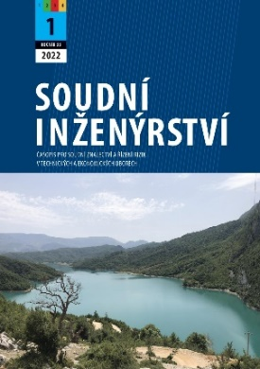 | 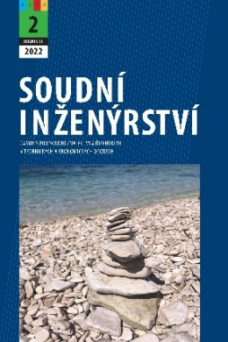 | 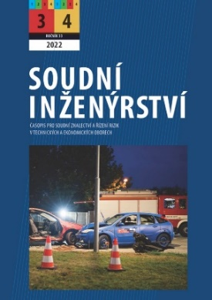 | 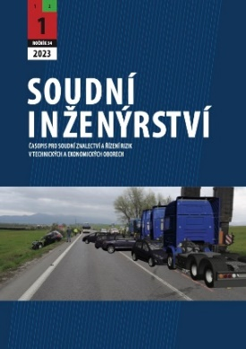
Figure 1 Cover pages of the last journals
Align the inserted image to the center of the page. If you have multiple images that you want to include side by side, we recommend using a table with an "invisible" border. Insert captions below the images and align them to the center of the page. The labels have a style called Label in bold (Figure #). Insert sources as a hyperlink using the Cross-reference function.
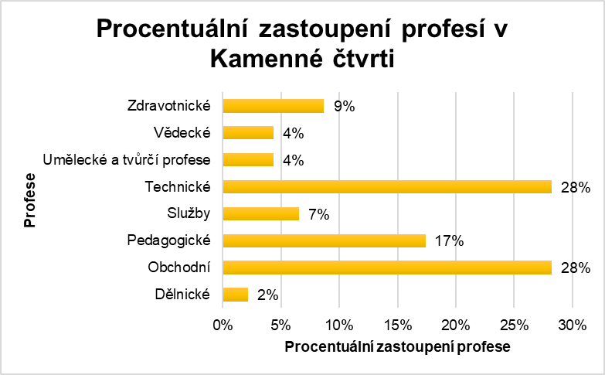
Graph 1 Representation of professions in the Stone Quarter in 2023 [2]
The format and visualization of the graph is a matter of choice. We recommend editing graphs using the adjacent MS Word sheet, as well as adjusting the size. Then insert it as an image into the template. This will prevent unwanted changes to the graphic visualization e.g., when using an older version of MS Word. As with images, insert the labels below the graph and align them to the center of the page. The labels have a style called Label in bold (Graph #). Sources should be hyperlinked using the Cross-reference function.
Table 1 Adhesion coefficient values for concrete road surface [3]
Material | Surface condition | Adhesion coefficient range
 |  | dry | wet
Concrete | new, rough | 0.70-1.20 | 0.40-0.80
 | light wear | 0.60-0.80 | 0.45-0.70
 | heavy wear | 0.50-0.75 | 0.45-0.65
The format and visualization of the table is a matter of choice. Manually indent the paragraph of your text below the table by 6p. Align table labels to the center of the page above the table. The labels have a style called Label in bold (Table #).
To create equations, use the insert equation feature included in MS Word. For better visualization, we recommend using a table with one row and two columns with "invisible" borders. Number the equations in the second column as shown in example (1) below. Ideally, be sure to refer to the equation in the text. To create a hyperlink to the numbering, use the Bookmark function and then insert a Cross-reference.
$$s=v_{0}∙t-\frac{1}{2}∙a∙t^{2},$$ | (1)
you can follow the equation with explanatory text e.g., time (t), initial velocity (v₀), and deceleration (a).
- Conclusion
On behalf of the editorial team of Soudní inženýrství journal, we thank you not only for honoring research ethics in your research activities but also for following this template.
- Acknowledgements
In this section you have the room to express your gratitude to both individuals and other partners involved in your research. Be sure to include any sponsors and grant numbers from which your research was funded.
- References
Please follow the current citation standard ISO 690:2022 and number the sources properly. We recommend using citation software. Use the text style of the cited literature titled Literature. Be sure to use italics for the title of the cited work as required by the citation standard.
- BRADÁČ, Albert a kol. Soudní inženýrství. Brno: CERM, 1997. ISBN 80-7204-057-X
- POKORNÁ, Sofie a FRANCOVÁ Klára. Proměna sociální struktury kamenné čtvrti. Sborník příspěvků konference Junior Forensic Science Brno 2023. Brno: Vysoké učení technické v Brně, Ústav soudního inženýrství, 2023. s. 88-95. ISBN: 978-80-214-6165-9.
- SEMELA, Marek. Analýza silničních nehod I. Druhé přepracované vydání. Brno: Vysoké učení technické v Brně, Ústav soudního inženýrství, 2016. ISBN 978-80-214-5037-0.

